Statistical LMs

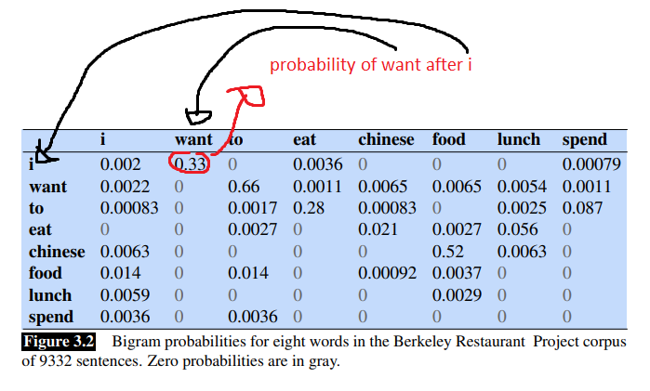

To check if “spend I spend to Chinese I eat”

We must check if a word is possible after the previous one

So first we check if “I” is possible after “SPEND” 🡪 to do this we look to column “I” and row “SPEND” (1)

“SPEND” after “I” (2)

“TO” after “SPEND” (3)

“CHINESE” after “TO” (4)

“I” after “CHINESE” (5)

“EAT” after “I” (6)

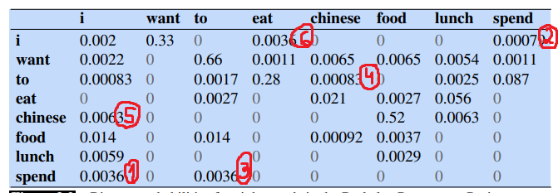

UNIGRAM PROBABILITY OF EAT

SUM OF ROW + SUM OF COL 🡪 probs of being before a wor,d and after another word









